**Experiment 8: Simple application using JSP**

**Aim:** To make a simple application using JSP.

**Implementation:**

**Output:**

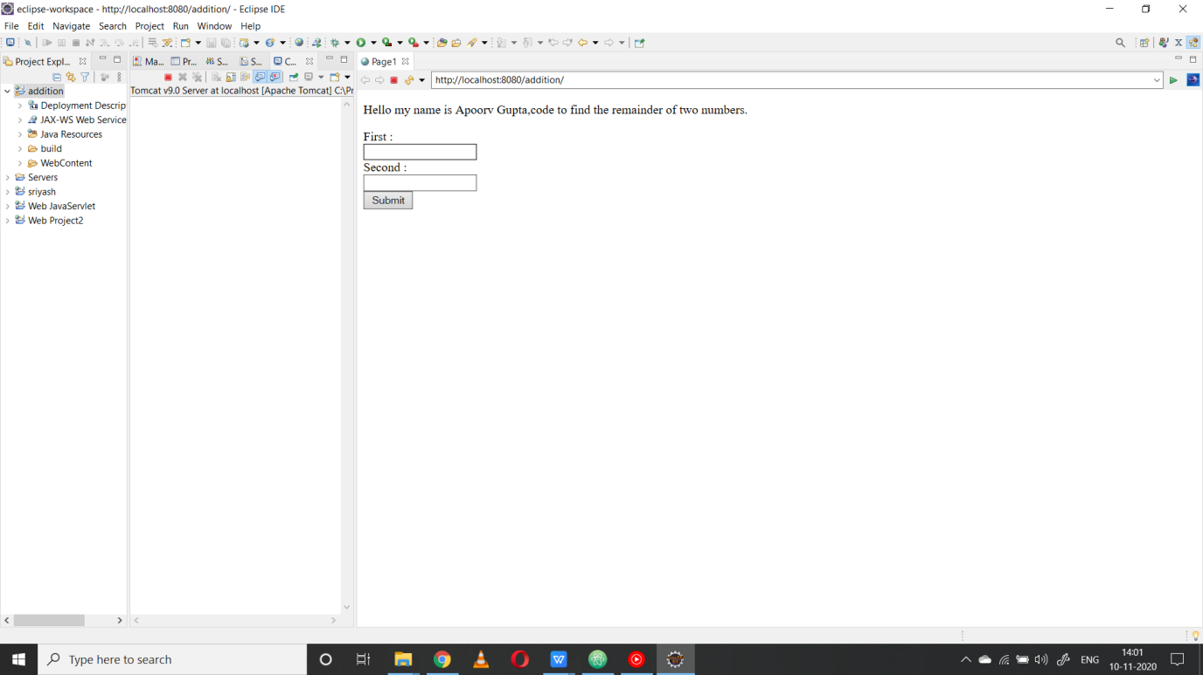

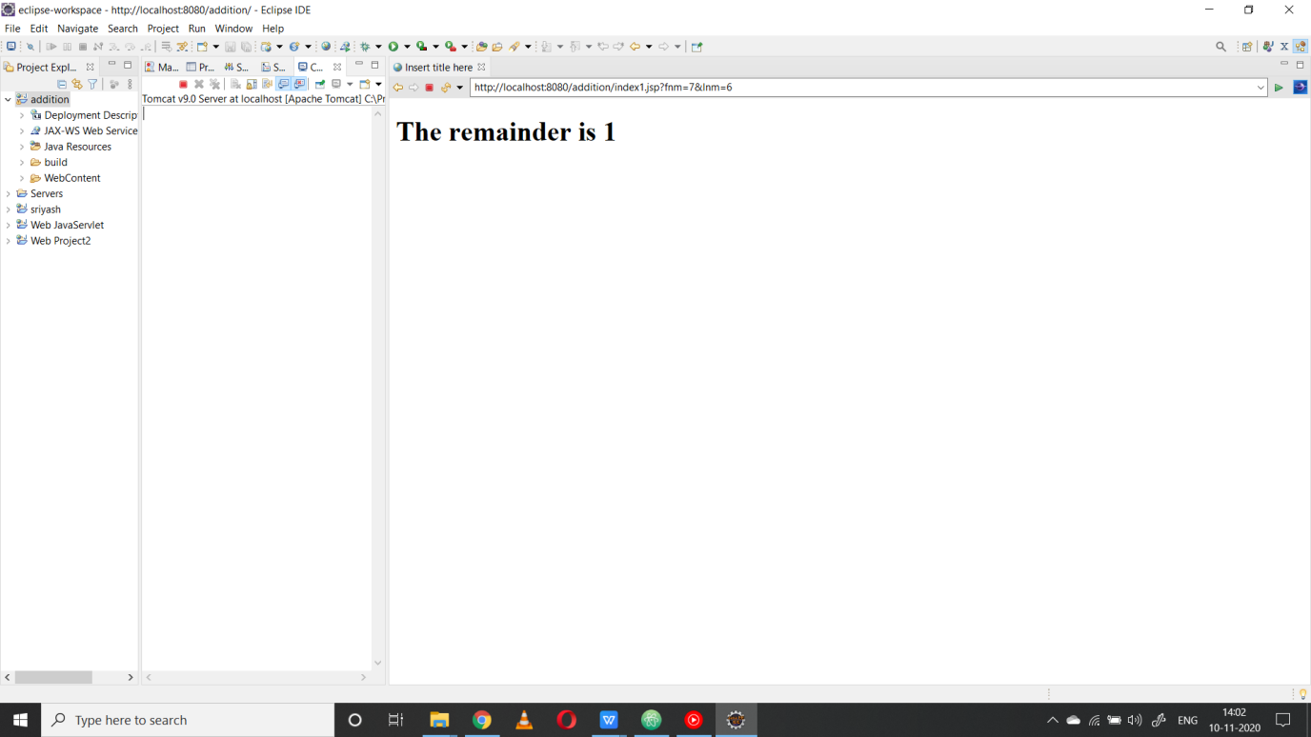

**Code:**

<%@ page language=*"java"* contentType=*"text/html; charset=ISO-8859-1"*

pageEncoding=*"ISO-8859-1"*%>

<!DOCTYPE html>

<html>

<head>

<meta charset=*"ISO-8859-1"*>

<title>Page1</title>

</head>

<body>

<P> Hello my name is Apoorv Gupta,code to find the remainder of two numbers.</P>

<form action=*"index1.jsp"* method=*"post\"*>

<label for=*"fnm"*>First :</label><br>

<input type=*"text"* name=*"fnm"*><br>

<label for=*"lnm"*>Second :</label><br>

<input type=*"text"* name=*"lnm"*><br>

<input type=*"submit"* value=*"Submit"*>

</form>

</body>

</html>

**Index1.jsp**

<%@ page language=*"java"* contentType=*"text/html; charset=ISO-8859-1"*

pageEncoding=*"ISO-8859-1"*%>

<!DOCTYPE html>

<html>

<head>

<meta charset=*"ISO-8859-1"*>

<title>Insert title here</title>

</head>

<body>

<%= "<h1> The remainder is "+(Integer.parseInt(request.getParameter("fnm"))%Integer.parseInt(request.getParameter("lnm")))+"</h1>"%>

</body>

</html>

**Result:**The experiment was successfully completed.